# DART Model

In the knowledge intensive economy the capacity to serve individual customers is becoming a major source of competitive advantage. Therefore the operational instruments enabling the managers to understand and implement new business models enhancing the capacity of value co-creation are welcome. Despite its importance, research on co-creation with customers is still at an early stage. In particular, there is a dearth of quantitative evidence, obtained through research methods other than case studies and other qualitative approaches. The DART model is considered to be an important step forward and a valuable attempt to indicate the range of companies’ capabilities necessary to effectively work with customers. It specifies the four main building blocks or groups of competencies that companies should develop to effectively engage in value co-creation with customers. Those blocks include Dialogue, Access, Risk Assessment and Transparency, which taken together form the DART acronym. Here we will use DART model to explain what our service best fit.

## Dialogue

From the meaning of Dialogue is to shared learning and communication between two equal problem solvers. We propose to create communication platforms that are popular in Vietnam:

* Facebook –via Facebook fanpage and Facebook group.
* Youtube channel
* Feedback form
* Surveys
* Notifications of apps/sms/email
* Emergency call center

Hence Facebook is the most used social network in Vietnam, GO-VIET should take advantages two of its features: fanpage and group. Fanpage is used to give out exclusive news. Group is for collecting opinions from users to company and vice versa. We suggest that we should use a join group for both consumers and partners

Meanwhile Facebook video functions is still lackluster, Youtube channel is the main way for video solution.

Feedback and survey are still an available option for getting opinions from customers, although they serve different objectives.

Push notification through apps, sms and email is also a solution for give news or personal informs for users.

Emergency call center is a must in all service, it not only for helping customers with emergency problems but also give solutions from data collected from critical case.

## Access

Customers and talents can access to our service via website or application in both PCs and mobile devices.

In PCs:

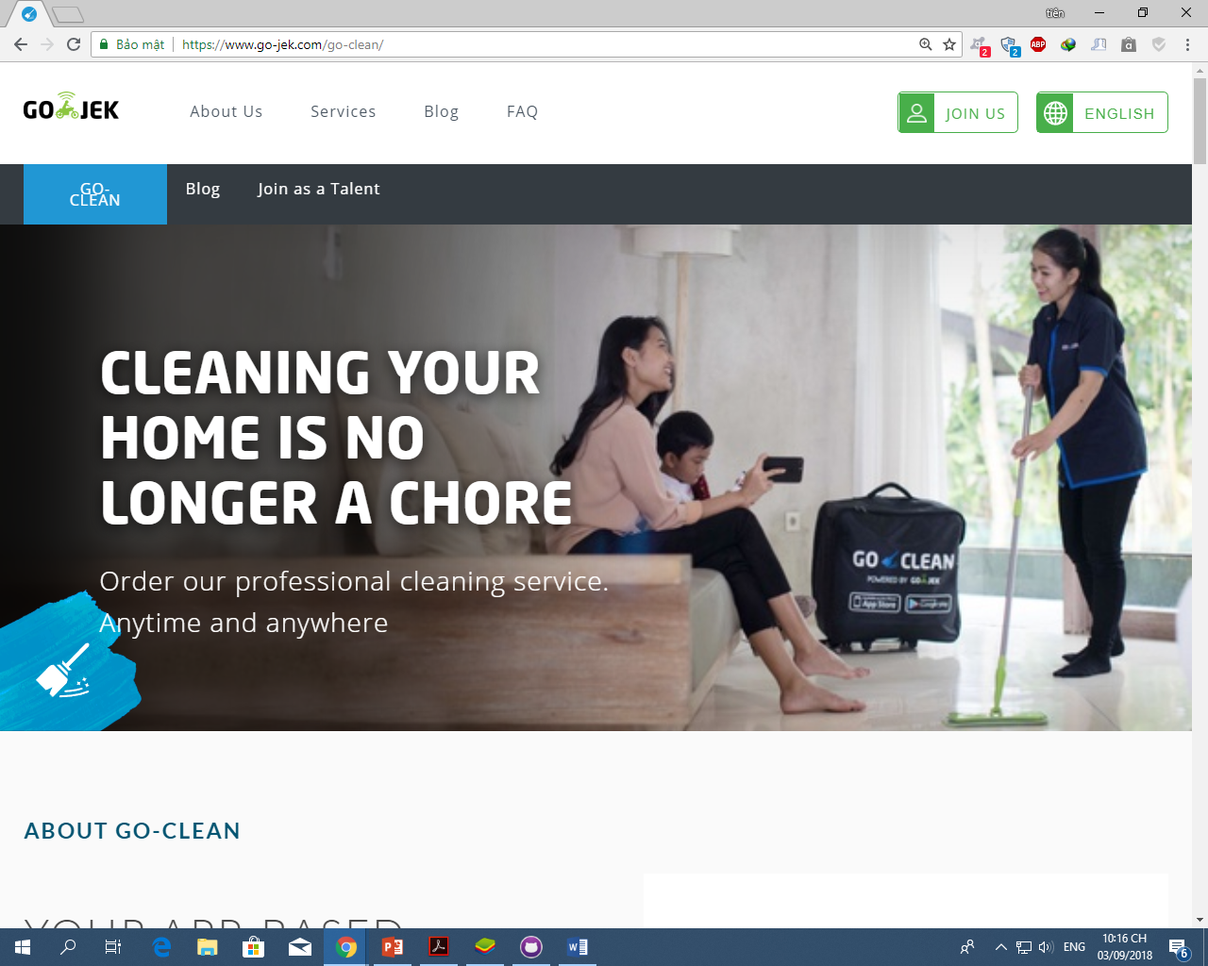

Register(talent):

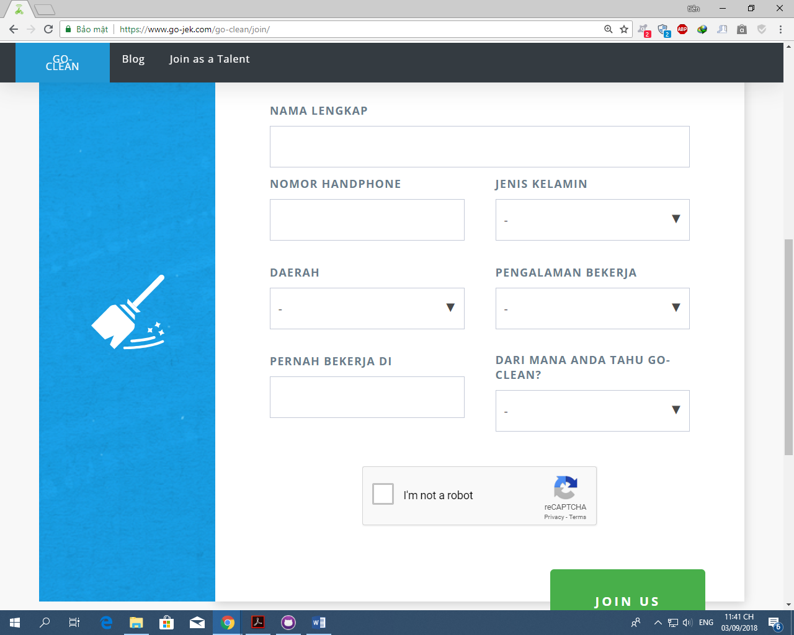

Blog:

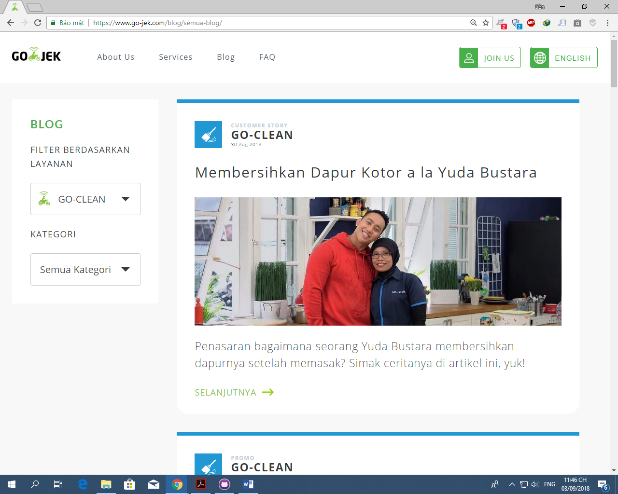

In mobile devices (it is a part of GO-LIFE in Indonesia):

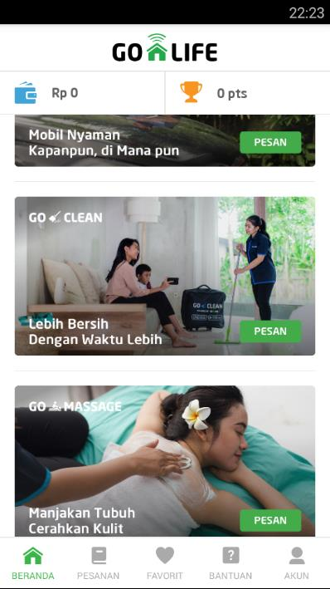

Consumers:

* + They can access in both application and website if they have account (using Facebook account or creating go-life account).
  + They can choose suitable service in option list area.
  + Consumers can judge Go-Clean cleaner
  + Consumers can see partner/talent information
  + Consumers can see all information of service include fee before deciding.

Partner:

* + Partner/talent can work with Go-Clean if they have talent accounts and verify by Go-Clean admin.
  + Partner/talent can use company equipment
  + They can see their information customers (limit)